The Promise Institute for Human Rights at UCLA, Annual Report 2025-2026

Vision
Founded in 2017 at UCLA School of Law, The Promise Institute for Human Rights at UCLA advances cutting-edge human rights education and scholarship, empowering the next generation of lawyers, scholars, and leaders to make meaningful impact in the world. The Institute serves as UCLA’s hub for education in human rights law, international humanitarian law, and international criminal law, engaged in applied research and advocacy, with locations in Los Angeles and Europe. Its vision is to promote globally inclusive approaches that connect people across borders and cultures through a common mission to promote universal human rights for all.

Mission
To provide the premier legal education in the intersecting fields of human rights, international humanitarian law, and international criminal law; empower the next generation of human rights lawyers, scholars, and leaders; and transform the promise of human rights into reality for more people around the world.

Strategic Goals
Provide the premier legal education in the field of human rights by offering globally-inclusive curriculum and experiential learning opportunities through clinical education and internships.
Generate and support impactful knowledge production, research, and scholarship in human rights, international law, and related fields.
Advance research-driven initiatives and programs that promote universal human rights, working with, not for, those we seek to serve.
Serve as the intellectual hub for human rights at UCLA and on the West Coast.
Advance UCLA’s mission and values as a public research university dedicated to education, research, public service, and the betterment of our global society.

The Year in Review
The 2025 - 2026 academic year saw the international human rights system under strain worldwide. Courts, treaty bodies, and special mandates faced political pressure, funding cuts, and open defiance as international law was violated with impunity around the world. The United States’ approach to both the international human rights system and the federal courts was central to that picture. In such a year, the case for training human rights lawyers—and the work of The Promise Institute for Human Rights—only grows stronger.
We are redoubling our efforts to meet this moment through education, legal advocacy, and scholarship. Retaining our core values of centering traditionally marginalized voices and placing affected communities at the heart of our work, this year we expanded our educational offerings with new courses on TWAIL and Black Traditions in international law, and supported post-graduate fellows in Sarajevo and in Ecuador. Our clinical team continued its work in support of unhoused people in the Los Angeles area, winning terminating sanctions in a case against the City of Los Angeles for constitutional rights violations, and we took students to Ecuador and to Honduras to examine whether landmark judgments on land use and the right to a healthy environment were being enforced. We were proud to be able to sponsor nine students’ externships at international organizations and tribunals through our UCLA Law in The Hague program.
As the climate crisis accelerated, our focus on the human right to a healthy environment included partnering on an amicus brief to the African Court of Human and Peoples’ Rights which argued that carbon offset markets in Africa reproduce patterns of land-grabbing and colonial exploitation. We also prepared a submission to the U.N. on the human rights consequences of U.S. nuclear testing in the Marshall Islands which framed the program's environmental effects as ecocide and crimes against humanity. Our students provided pro bono research support to the U.N. Special Rapporteur for the first-ever report on the human right to sanitation. Our new “Manual on Prosecuting International Environmental Crimes,” developed with Climate Counsel and drawing on experience from Ukraine, is designed for use at the local and national levels to promote accountability for widespread and systematic attacks on the environment.
The Promise Institute continues to deepen connections between practitioners and academics, working to ensure that the research generated at UCLA can be practically applied in the human rights community globally. In October, we convened scholars from across the globe to discuss Ecocide, Human Rights and Environmental Justice at the University of London. This international conference showcased researchers, politicians, activists, and diplomats, in particular from the Global Majority, and accompanied a dedicated issue of the International Journal of Human Rights. In January, we hosted our annual symposium at UCLA entitled “Human Rights and the Crisis of World Order” which examined the shifting landscape of human rights as we see the rise of authoritarianism and a decline in the rule of law globally. We also held events on human rights in El Salvador and Sudan, brought practitioners to campus to speak about nontraditional routes to human rights work, and hosted a screening of a documentary on the right to water.
As we look forward to 2026 - 2027, we redouble our commitment to building resources at the local and national levels to strengthen human rights at this critical time. We thank Professor of Law Anna Spain Bradley, who stepped down as Faculty Director at the end of the academic year and stays with us as affiliated faculty; her tenure strengthened the Institute’s intellectual breadth and ties across the University. As the new academic year starts, we warmly welcome Professor Kal Raustiala as incoming Faculty Director, and UCLA Law alumna Hadar Harris as Executive Director in Los Angeles. A longtime advocate for justice, equity, and human rights, Harris brings more than two decades as an international human rights attorney with experience in more than 25 countries.
Thank you to you, our community at UCLA and beyond, for being allies in this work.
Catherine Sweetser, Interim Executive Director, Los Angeles
Kate Mackintosh, Executive Director, Europe

Land Acknowledgement
UCLA School of Law acknowledges the Gabrielino/Tongva peoples as the traditional land caretakers of Tovaangar (Los Angeles basin, So. Channel Islands). As a land grant institution, we pay our respects to the Honuukvetam (Ancestors), 'Ahiihirom (Elders), and 'Eyoohiinkem (our relatives/relations) past, present, and emerging.

Meet the Team

Anna Spain Bradley, Faculty Director, Professor of Law
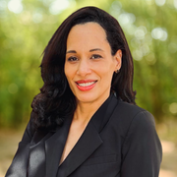
Kate Mackintosh, Executive Director (Europe)

Catherine Sweetser, Interim Executive Director (Los Angeles)

Joseph Berra, Human Rights in the Americas Project Director

Amanda Brown, Legal Advisor (Europe)
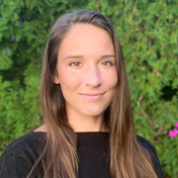
Xuchen Zhang, Legal Advisor (Europe)

Amrin Vajifdar, Program Coordinator (Los Angeles)

Jeanine Hovius, Communications Director (Europe)
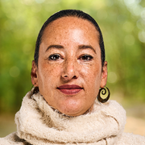
Natalie Monsanto, Communications Director (Los Angeles)

Kimberlé Crenshaw, The Promise Institute Chair in Human Rights

Kal Raustiala, The Promise Institute Chair in Comparative and International Law


Education & Student Opportunities

Human Rights Litigation Clinic
The Human Rights Litigation Clinic assisted co-counsel with briefing and preparation for oral argument at the United States Supreme Court in April. The case focuses on accountability for the actions of U.S. corporation Cisco. Plaintiffs alleged that Cisco created software intended for use in, and that was used to, facilitate religious persecution in China. Students Raafiya Ali Khan J.D. ‘27, Grace Kowalevsky J.D. ‘27, and Danial Haschem LL.M. ‘26 were instrumental in preparing the team for the international law portions of the case. Unfortunately, the Court ultimately ruled against us, but the Clinic will continue to assist advocates as they bring forward state law claims.
The Clinic was also appointed class counsel in a case about the use of force in the Adelanto Detention Facility. The civil detainees there engaged in a peaceful protest, and The GEO Group, Inc., the corporation running the facility, used force against the detainees. Our clients allege the corporation saturated their units with pepper spray and failed to adequately clean it afterwards or allow them to decontaminate properly.
The team in Garcia v. Los Angeles won an important victory granting terminating sanctions due to the City’s spoliation of evidence about clean ups that result in unhoused people losing their personal property without due process. The court found that “Due to the scope and severity of the City’s misconduct . . . no lesser sanction would remedy the effects of the City’s spoliation or adequately deter the City from engaging in similar misconduct in the future.” In further briefing on injunctive relief and damages, our clients explained that the unconstitutional sweeps result in people losing vital property—including mementos of loved ones they have lost, property that helps them stabilize their lives, and items they need to secure housing.
This Spring, we also engaged in a cross-clinic collaboration with the Emmett Institute on Climate Change & the Environment's Frank G. Wells Environmental Law Clinic. The effort saw students from both clinics traveling to Ecuador to assist Indigenous communities in opposing fossil-fuel infrastructure which is harming Amazonian communities and their environment. The clinics have filed an amicus brief with the Ecuadoran Constitutional Court to support enforcement of an order to reduce and ultimately eliminate gas flaring in the region.
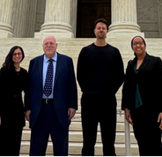
Raafiya Ali Khan, Paul Hoffman, Danial Haschem, and Cathy Sweetser on the steps of the Supreme Court.
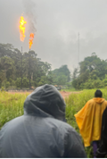
Observing a gas flare in the Ecuadorian Amazon.

Quote
“Civil detainees do not give up their First Amendment rights under the California or federal constitutions when they are detained.”
Central District Court, Order Denying Defendant’s Motion for Summary Judgment in Gonzalez v. The GEO Group, Inc., Case No. 2:22-cv-04014

Human Rights in Action Clinic
In 2026, the Human Rights in Action Clinic returned to Honduras to continue fieldwork with the displaced and dispossessed Indigenous Lenca communities of Nueva Esperanza and Achiotal. The Honduran state has denied their claims to collective title to their land and subjected them to criminal proceedings.
In coordination with local partners, Consejo Cívico de Organizaciones Populares e Indígenas de Honduras and the Bufete Justicia para los Pueblos, we are accompanying these communities in their struggle to regain access to their lands in the ongoing wake of settler colonization. During fieldwork the Clinic documented human rights violations, reviewed the criminal proceedings’ court files, and researched the lands’ chain of title.
The community of Nueva Esperanza (“New Hope”) is challenging their criminal proceeding and forced displacement. They now live precariously on the side of the road. Clinic students shared a memo with the Bufete which outlined due process violations the community had endured. In June, the Bufete filed a constitutional challenge (known as an “amparo” in Spanish) on due process grounds. Students also prepared an amicus brief in support of the community’s claims based on the Inter-American Court of Human Rights’ jurisprudence, which the Clinic will file once the amparo is admitted by the Supreme Court.
The criminal case against community members of Achiotal is going to trial. Clinic Director Joe Berra will be offered as an expert at the trial on the rights of Indigenous people to access land in their traditional territory.
Clinic students produced an extensive memo analyzing the history of Lenca territorial dispossession, arguing that “traditional territory” includes currently dispossessed ancestral lands. The analysis is clear: the community has a right of access to traditional land for their survival, and the State has an obligation to ensure access to the land they seek.
The Clinic also returned to the Garífuna community of Triunfo de la Cruz, where we conducted fieldwork in 2024. Following our report from the field, ”Garífuna Territorial Reparation,” we documented the ongoing eﬀorts of the community to implement and enforce the Inter-American Court of Human Rights’ 2015 judgement which recognizes their collective property rights. Since the Clinic’s 2024 ﬁeldwork, the community has increased the direct reoccupation of their land as a means of enforcing the Court’s judgment.
Through firsthand experience students engaged directly with impacted communities, human rights defenders, and regional international human rights systems to support and advance their struggle.
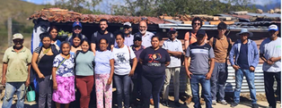
Visiting the current site of Nueva Esparanza—situated precariously along a road following Honduran government actions to deny the community access to their ancestral Indigenous lands.

UCLA Law in The Hague
This flagship experiential program gives UCLA Law students unparalleled opportunities to engage directly with international law and human rights. Participants spend a semester interning in The Hague and participating in a seminar taught by The Promise Europe Executive Director Kate Mackintosh. They visit the United Nations in Geneva, gaining firsthand experience at the heart of international justice.
This academic year, we placed nine students at prestigious courts, tribunals, and international organizations. At many of these institutions, we remain unique in having an internship pipeline for current law students.
The program's impact reaches well beyond the semester abroad: returning students bring their insights and experiences back to enrich international law courses in Los Angeles. We continue to cultivate a cohort of graduates who see careers in international institutions not as distant aspirations, but as real, attainable paths.

Quote
"The UCLA Law in The Hague program was everything I hoped it could be and more. I met profoundly inspiring people, worked on meaningful projects, and made some of my favorite law school memories. Being able to do this while still being a law student is an incredibly unique opportunity that I would encourage everyone to take advantage of!”
John Dover, UCLA Law J.D. Student, Class of 2026

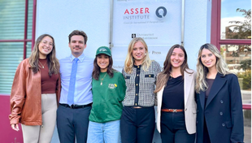
Fall 2025 students outside the T.M.C. Asser Instituut in The Hague, where they complete a two-credit international law course with Professor Kate Mackintosh throughout the semester.

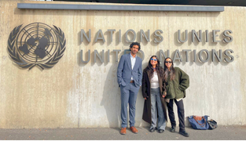
Spring 2026 students in Geneva for the UN Human Rights Council.

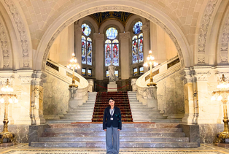
Student Ayisha Siddiqa at the Peace Palace, where she completed an internship at the International Court of Justice.

Events

Los Angeles Events

Human Rights in El Salvador: Deportation and Detention
Human Rights in El Salvador: Deportation and Detention, featured lawyers and a UCLA Law student handling cases related to arbitrary detention there. One attorney discussed representing Salvadorans arbitrarily detained as part of the gang enforcement measures in the country, while another discussed representing clients deported to El Salvador from the United States. Speaker identities withheld for security.
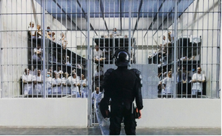
Image of a cell block in CECOT in El Salvador.

Career Talks
As career development is an important aspect of the institute’s focus, we bring speakers to meet with law students to talk about their career path. Among the speakers this year were Center for Constitutional Rights senior attorney Katie Gallagher and three law firm partners running human rights focused practice groups within their firms: Monique Alarcon, Agnieszka Fryszman (not pictured), and Christina Hioureas.
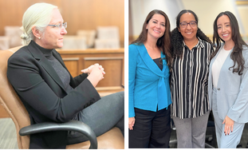
Katie Gallagher, Christina Hioureas, Cathy Sweetser, and Monique Alarcon.

What is Happening in Sudan
Sudan has been devastated by war over the past two years and hundreds of thousands of people have fled the conflict, facing starvation and terrible conditions in refugee camps.⁠ To draw attention to this underreported conflict, What is Happening in Sudan? featured former Human Rights Watch researcher and expert on Sudan, Jehanne Henry⁠ discussing documentation efforts.⁠
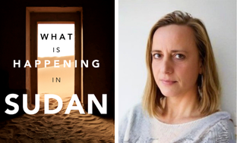
Flyer for event and speaker, Jehanne Henry

Holding Corporations Accountable for Human Rights Violations
Marissa Vahlsing, the U.S. Litigation Director of EarthRights International, joined Colombian legal advocates Daniel Marín López of the National University of Colombia, and Juan Pablo Guerrero of CINEP to discuss the opportunities and pitfalls in litigating Colombian tort claims in U.S. courts and the justice and peace process in Colombia.
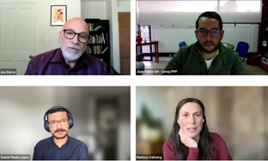
Speakers during the Zoom event.

Featured Affiliated Faculty
Highlighting the work of the institute’s Affiliated Faculty, we brought (in image below from left to right) Professors Ann Karagozian of The Promise Armenian Institute, Shannon Speed of the American Indian Studies Center, and David Myers of the Bedari Kindness Institute (among other affiliations) to the law school to meet with students throughout the spring.

Ann Karagozian, Shannon Speed, and David Myers.

Film Screening: “Water for Life”
Together with partners, we screened “Water for Life,” which follows three Indigenous leaders—Berta Cáceres, Francisco Piñeda, and Alberto Curamil—who stood up to powerful industries to protect their communities’ water. The panel that followed discussed local efforts to protect water in Payahuunadü (the Owens Valley), with Teri Red Owl, AnMarie Mendoza, and Jessica Cattelino.
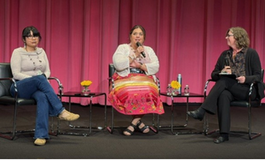
Speakers during the film screening.

Symposium: Human Rights and the Crisis of World Order
Our 2026 symposium, Human Rights and the Crisis of World Order, included a keynote address from United Nations Special Rapporteur on the rights of Indigenous Peoples, Dr. Albert Barume. Panelists explored the role of legal frameworks and international institutions in orienting the world towards human rights, and the continued relevance of human rights for social action and transformative justice.
Speakers included, pictured below, from left to right and top to bottom: Dr. Albert Barume, Prof. Roxanna Altholz, Alejandra Ancheita, former President of the Inter-American Commission on Human Rights Roberta Clarke, Prof. Scott Cummings, Prof. Cheryl Harris, Prof. Saira Mohamed, Prof. Obiora Okafor, Prof. Jaya Ramji-Nogales, Sophie Richardson, Prof. Cesare Romano, Prof. Lauren van Schilfgaarde, and poet Momo Alvarado. The Record of Proceedings is available on our website.
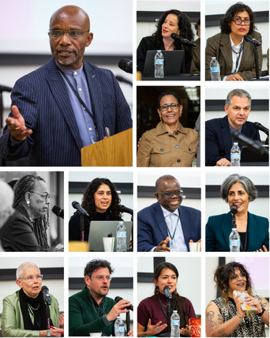

Europe Events
To mark the third anniversary of the destruction of the Kakhovka Dam, we launched our “Manual on Prosecuting International Environmental Crimes” at an event in The Hague, organized by the Embassy of Ukraine in the Kingdom of the Netherlands. Drafted in partnership with Climate Counsel, the “Manual” takes the lessons learned from the Ukraine context to build a guide to framing environmental harm as an international crime that can be applied in both conflict and peacetime, in any jurisdiction around the world.
Opened by Ambassador Andriy Kostin of Ukraine, the program brought together experts from government, international organizations, civil society, and legal practice to reflect on the devastating impact of the Kakhovka Dam incident, and the role of international criminal law in preventing severe environmental harm. Using Ukraine’s painful experience as a starting point, the discussions ranged from concrete prosecution strategies through legal framing to questions of evidence and future deterrence.
We also co-hosted a side event on the same topic for delegates to the ICC’s annual December meeting in The Hague, chaired by The Promise Institute Legal Advisor Xuchen Zhang and featuring international and Ukrainian experts.
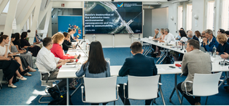
A full house in The Hague for the ”Manual’s” launch. Photo by Valeria Manzovitova.

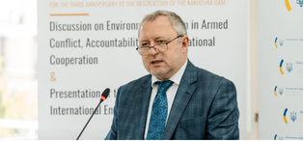
Andriy Kostin, Ambassador of Ukraine to the Kingdom of the Netherlands, provided opening remarks. Photo by Valeria Manzovitova.

In Amsterdam and Leiden, we hosted a series of events with Professor Alex Wang, exploring his new book “Chinese Global Environmentalism.” Drawing on examples from investment, diplomacy, and development cooperation, he examined how China is shaping environmental governance and influencing global norms. Across three events, Prof. Wang was joined by experts Shiming Yang and Benjamin van Rooij.
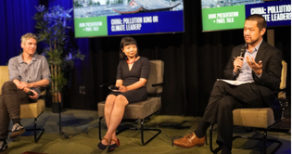
Benjamin van Rooij, Shiming Yang, and Prof. Alex Wang.
In the Fall, we co-organized the International Conference on Ecocide, Human Rights and Environmental Justice, hosted by the Institute for Commonwealth Studies, University of London. Speakers from around the world presented papers selected for publication in our forthcoming “Special Issue of the International Journal of Human Rights.”

Second Annual Judging International Justice Lecture
We were proud to hold the second annual Judging International Justice Lecture this Spring, featuring the Honorable Dire Tladi, Judge at the International Court of Justice. He examined the role of the ICJ, reflecting on concepts such as jus cogens and erga omnes. Professor of Law Anna Spain Bradley guided the conversation towards the role of the ICJ in sustaining trust in international legal institutions as they come under increasing pressure.
This annual lecture series, launched in 2025, advances The Promise Institute's mission to foster meaningful public engagement with efforts to promote international justice and human rights through law. Held at the T.M.C. Asser Instituut in The Hague, the lecture reflects the mission of our Europe location: to remain closely connected to the institutions at the heart of international law.

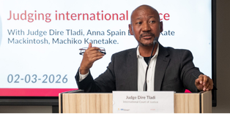
Judge Dire Tladi delivering his lecture. Photo by Anisa Xhomaqi.

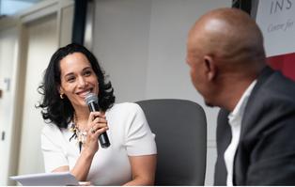
Professor Anna Spain Bradley reflecting on Judge Tladi’s lecture. Photo by Anisa Xhomaqi.

A.S.I.L. Annual Meeting
Professor Máximo Langer, The Promise Faculty Director Professor Anna Spain Bradley, and The Promise Europe Executive Director Kate Mackintosh were among the speakers at this year’s American Society of International Law (ASIL) Annual Meeting in Washington, D.C. in April, which was attended by a number of UCLA Law faculty and students.
Professor Langer spoke on the panel "Fragmented Nuremberg," which examined how the Nuremberg legacy has splintered across today's institutional landscape and assessed the shape of international criminal accountability for the decade ahead, as such mechanisms face growing political pressure. Kate Mackintosh was featured in the closing plenary on strategic litigation in international law, calling for creative thinking about the potential of existing institutions and legal frameworks, including the under-explored role of international criminal law in addressing environmental harm. Professor Anna Spain Bradley also spoke on an ASIL panel organized by ASIL’s Women in International Law Interest Group.

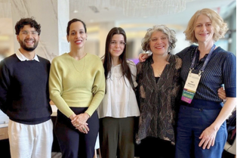
Students Aniq Chunara and Debby Rab with Professor Anna Spain Bradley, incoming The Promise Los Angeles Executive Director Hadar Harris, and The Promise Europe Executive Director Kate Mackintosh at the ASIL Annual Meeting in Washington D.C.

Research & Scholarship

Books

Kimberlé Crenshaw, “Backtalker”
Professor Kimberlé Crenshaw, The Promise Institute Chair in Human Rights at UCLA Law, has published “Backtalker: An American Memoir”—a New York Times bestseller. Professor Crenshaw has played a significant role in the shaping of Critical Race Theory, and her groundbreaking work introduced the concept of intersectionality. In this memoir, she describes the experiences that shaped her ideas and lifelong commitment to challenging injustice.



Karen McCarthy Woolf, “Unsafe”
Karen McCarthy Woolf's new poetry collection, “Unsafe—A 21st Century Poetry of Witness,” brings together work developed during her residency at The Promise Institute in 2019 and 2020. As a disenchanted walk through London and Los Angeles, Unsafe shows the effects of capitalism on those who live at its sharp end. It was selected as a Poetry Book Society Choice and featured as a Book of the Month in “The Observer.”


Alex Wang, “Chinese Global Environmentalism”
In his new book, Professor Alex Wang examines how China came to embrace green development and the ways in which China promotes a developmental form of environmentalism globally, through tools of green ideology, diplomacy, economic statecraft, and development cooperation. The book features several case studies that shed light on China’s approach, including Chinese green investment in Chile, environmental conflicts in Kenya, hydropower development in Southeast Asia, global climate negotiations, and Chinese dominance in clean technology development.
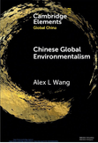

Quote
“Working as a Research Assistant for The Promise Institute has been one of the most enriching experiences of my studies. The work ranges from organizing important events to engaging with academia through deeper analysis, pushing me to think beyond the boundaries of law school. It has kept me updated on the many challenges international law faces today and given me a front-row seat to how great minds are working to solve them."
Santiago Bustos García, LL.M. ‘26

Journal Articles

Amanda Brown, “CRT and the Law of the Sea: Bringing Critical Race Theory ‘Offshore’”
In the “SOAS Journal of Postgraduate Research,” The Promise Legal Advisor Amanda Brown highlights a lack of interaction between Critical Race Theory (CRT) and the international law of the sea, despite CRT’s growing influence across other areas of international law.

Máximo Langer, Universal Jurisdiction & Alien Tort Statute
Professor Máximo Langer introduced a new analytical category of universal jurisdiction defendants in his article “Living with impunity versus living in fear” in the “Leiden Journal of International Law.” In another new article, “Immigration, Justice Remittances, and U.S. Courts” in “International Studies Quarterly,” he examined the implications of the Alien Tort Statute as justice remittances.

Kate Mackintosh & Lisa Oldring, Ecocide in the Alberta Tar Sands
Kate Mackintosh and Lisa Oldring published an article in “The International Journal of Human Rights” considering “The archetypal ecocide: is environmental devastation in the Alberta oil sands an international crime?” Applying the contemporary proposed definition of the international crime of ecocide to the Alberta oil sands operations, they highlight the ecological devastation caused and explore the nuances of the proposed definition.

Jess Peake, Power and Humility in Open Source Investigations
Director Jess Peake of UCLA Law’s International and Comparative Law Program, along with Alexa Koenig and Sylvanna Falcón, authored an article in “Human Rights Review” drawing on their legal and sociological training to explore the role of power and humility in the quickly-emerging field of Open Source Intelligence (OSINT).

Kal Raustiala, Whoever Rules the Waves Rules the World: Sea Power and the Law of the Sea
In the “American Journal of International Law,” Professor Kal Raustiala examines the evolving trajectory of the Law of the Sea through contemporary debates, including China’s activities in the Arctic, deep seabed mining, and the South China Sea dispute. The paper offers timely insight into how sea power continues to shape the international legal order.

Catherine Sweetser, Trauma-Informed Lawyering Leads to Movement Lawyering in International Human Rights Work
This article by Catherine Sweetser in the “UC Irvine Journal of International, Transnational, and Comparative Law” explores how trauma-informed lawyering is a way to reconcile the imperative of client-centered lawyering with community or movement lawyering, particularly in international human rights law.

Other Publications

Book Chapter: Ecocide and Human Rights
Senior Fellow Lisa Oldring and Kate Mackintosh contributed a chapter on "The Crime of Ecocide Through Human Rights: Towards Environmental Protection and Justice", in Burgers et al. (Eds), “Ecocide: Criminalising harm against the Environment.” The chapter argues that a human rights approach to the crime reveals the disparate impacts of environmental destruction on vulnerable and marginalized individuals and groups, and that prosecutions which reflect the reality of these lived experiences hold greater potential to contribute to environmental and climate justice.

Articles: Ecocide and Human Rights
Two shorter pieces examine how international law can and should address the climate crisis. In "Ecocide is the Missing Crime", published in “Icarus Complex Magazine,” Kate Mackintosh argues that when ecosystems collapse, so do the conditions for human dignity. Environmental destruction harms the most marginalized first; making ecocide a crime is not only an environmental necessity but a human rights imperative. In "How wars ravage the environment – and what international law is doing about it”, published in “The Conversation,” Kate Mackintosh and Benjamin Neimark examine how war contributes to the climate crisis and how international law is beginning to respond. They highlight the long-term environmental and climate consequences of armed conflict, highlighting the massive greenhouse gas emissions of the wars on Ukraine and Gaza.

Bibliography: Ecocide Law Bibliography
The Promise research assistants John Dover and Ayodele Babalola updated our annotated bibliography on international criminal law and environmental protection published at EcocideLaw.com.
This comprehensive resource hub, first developed by UCLA Law students in 2020, provides a regularly updated collection of academic and legal material relating to ecocide law, including definition(s), history, research articles, existing laws and related topics. This year we saw a surge in scholarship on international law and the protection of the environment, with a particularly large number of papers focusing on the environmental damage caused by war.
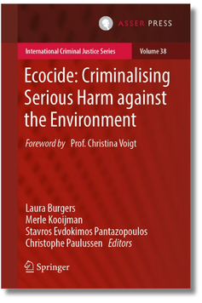
Cover of Ecocide: ”Criminalising Serious Harm against the Environment, featuring a book chapter by Kate Mackintosh and Lisa Oldring.”

Policy, Advocacy, and Pro Bono Work

2026 Symposium “Record of Proceedings”
In January, we hosted our annual symposium at UCLA School of Law, this year on the topic “Human Rights and the Crisis of World Order.” The symposium addressed the structural challenges facing global governance in the context of a shifting world order, particularly the growing vulnerability of international institutions.
Within this framework, the panels sought to explore where the human rights project currently stands in relation to the broader struggle for human dignity, and to examine how existing legal frameworks and international institutions are responding—or failing to respond—to these challenges.
Featuring a keynote from Dr. Albert Barume, U.N. Special Rapporteur on the rights of Indigenous Peoples, the Record of Proceedings captured important perspectives from each of the speakers.

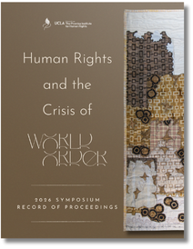
The “Record of Proceedings” is available on our website.

“Manual on Prosecuting International Environmental Crimes”
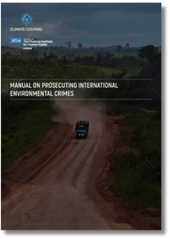
The “Manual” is available on our website
The “Manual” on Prosecuting International Environmental Crimes is based on expertise we gained supporting Ukraine’s efforts to investigate and prosecute environmental harm resulting from Russian aggression. Drafted in partnership with Climate Counsel, the “Manual” takes the lessons learned from the Ukraine context to build a guide that applies in both conflict and peacetime, in any jurisdiction around the world.
The “Manual” sets out the legal architecture for prosecuting environmental destruction and demonstrates how these legal tools can be applied in practice. It offers a step-by-step guide to what can be done within existing legal frameworks while helping to build the practical foundations that any future international crime of ecocide will also require. It also includes five case studies that work with fictionalized examples of contemporary environmental destruction to demonstrate how legal accountability can be pursued in practice.

U.N. Special Rapporteur on Water and Sanitation
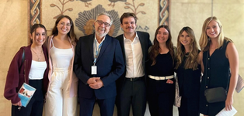
U.N. Special Rapporteur Pedro Arrojo-Agudo with UCLA Law in The Hague students in Geneva.
This year, UCLA Law students provided pro bono support to U.N. Special Rapporteur on the human rights to water and sanitation, Mr. Pedro Arrojo-Agudo, under the guidance of UCLA Law alum and The Promise Legal Advisor Amanda Brown.
In the Fall, 13 students conducted research for a forthcoming policy brief co-published by the Special Rapporteur and The Promise Institute on the weaponization of water in conflict. Students analyzed the intersections of water, conflict, and human rights in six different conflicts, highlighting key obligations of States under international humanitarian law, international criminal law, and international human rights law.
In the Spring, 11 students conducted research for his upcoming report to the U.N. General Assembly on the human right to sanitation without discrimination. Students researched the scope of the right to sanitation, studying national constitutions across the globe to catalogue which countries recognize the right to sanitation and how that right is defined. They also analyzed how the right to sanitation has been discussed in academia, civil society, and the U.N. ecosystem.

Communication to the U.N. H.R. Committee
In the Spring, 23 UCLA Law students conducted legal research in support of a forthcoming individual communication to the U.N. Human Rights Committee on behalf of a survivor of a summary expulsion (“pushback”) from Greece to Turkey. Under the guidance of The Promise Legal Advisor Amanda Brown, who is part of a legal coalition representing the survivor, students contributed research and analysis on various human rights violations.

Ecocide Advocacy
We raised our profile as a source of legal expertise on ecocide. The Promise Europe Executive Director Kate Mackintosh advised the Croatian Bar Association on implementing the EU's revised Environmental Crime Directive, and was invited to present at the U.N. Forum on Business and Human Rights in Geneva on how criminal liability for individual directors creates a real deterrent against environmental destruction.

The Climate Cost of War
We continued to address the climate impacts of war with Kate Mackintosh’s appearance on Al Jazeera’s “Inside Story:” “Is war one of the biggest threats to the world's climate?” The program examined why the environmental cost of war was left off the agenda at COP30, and whether an international crime of ecocide could shift accountability—set against the backdrop of the conflicts in Ukraine and Gaza.

Amicus Curiae: Carbon Markets and Human Rights
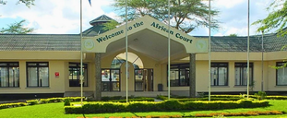
The African Court of Human and Peoples’ Rights in Arusha, Tanzania. Photo from the Court’s website.
Carbon offsetting projects are expanding across Africa. But at what cost? Together with partners Climate Counsel, Sudan Human Rights Hub, and SOMO, members of The Promise Europe team submitted an amicus brief to the African Court on Human and Peoples' Rights, for its forthcoming advisory opinion on human rights and climate change, raising urgent concerns about human rights impacts of carbon offsetting.
The amicus makes three key points: First, by enabling continued greenhouse gas emissions under the guise of mitigation, carbon markets perpetuate climate change and its human rights impacts.
Second, the implementation of carbon offset projects across Africa has generated consistent reports of serious rights violations, including land grabs and forced evictions, failure to consult communities, and environmental harms.
Third, carbon markets reproduce patterns of foreign exploitation prohibited by Article 21 of the Charter, which guarantees peoples’ rights to freely dispose of their natural resources and to be free from foreign economic exploitation.

U.N. Submission: Nuclear Legacy of the Marshall Islands
From 1946 to 1958, the United States detonated 67 nuclear weapons on Bikini and Enewetak Atolls in the Marshall Islands. These tests resulted in forced displacement, profound cultural loss linked to the destruction of land, and severe biological and ecological harm, consequences that continue to affect communities and environments today.
The Promise Institute was approached to contribute to the U.N. Human Rights Office report on addressing the challenges and barriers to the full realization of the human rights of the people of the Marshall Islands stemming from the State’s nuclear legacy.
The submission addresses how justice can be pursued for the impacts of nuclear testing on the environment, affected communities, and future generations. It concludes that the nuclear testing program, particularly its environmental effects, could amount both to the proposed crime of ecocide and to crimes against humanity under international criminal law as it existed at the time.
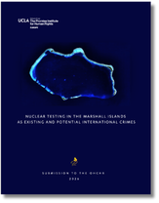
The full submission is available on our website.

Our Founding Story: Awareness Through the Arts
The Promise Institute owes its founding to Dr. Eric Esrailian, producer of the film “The Promise.” As the first feature film to tell the story of the Armenian Genocide, “The Promise” is a powerful example of the way art can connect history to action. The Armenian Genocide began in 1915, and in time more than 1.5 million people would perish in an atrocity driven by ethnic and religious intolerance.
Following the film’s premiere, Dr. Esrailian and fellow producer Anthony Mandekic used the film’s proceeds to launch our institute. “The Promise Institute is so named because we are making the promise to refugees and people suffering from injustice that we will create the tools and train the people to address these crises.”
The 2023 launch of the Europe location of The Promise Institute builds on this legacy, broadening the reach and impact of this work, and creating additional opportunities for law students training in the field of international justice. “This institute is needed now more than ever,” Dr. Esrailian said. ”Given what is happening across the globe, it is clear what we risk when the perpetrators of human rights violations feel emboldened by the lack of consequences.”

Official Film Poster.

Director Terry George with Dr. Eric Esrailian, Oscar Isaac, and Christian Bale.

Back Cover: Contact Information

Los Angeles

Follow
LinkedIn, Instagram, and YouTube: @promiseinstUCLA

Explore
promiseinstitute.law.ucla.edu

Contact
promiseinstitute@law.ucla.edu
385 Charles E. Young Drive, East, Los Angeles, California 90095

Europe

Follow
Bluesky, LinkedIn, Instagram, and Youtube: @uclapromiseeurope

Explore
Law.ucla.edu/academics/centers/promise-institute-europe

Contact
uclapromiseeurope@law.ucla.edu
Nieuwe Achtergracht 164, 1018 WV Amsterdam, The Netherlands

